

**Project Report**

**By:**

SHAKIR ALI

HAMMAD MEMON

AADESH BHATIA

**SUPERVISOR**

Respected: Sir ABID

|  |  |  |
| --- | --- | --- |
| **S. No** | **Contents** | **Page No** |
| **1** | **User Guide** | **6** |
| **2** | **PRESENTATION TIER** | **7** |
| **3** | **Home Page Screen Shots** | **8** |
| **4** | **Shop Page Screen Shots** | **9** |
| **5** | **Contact Page Screen Shots** | **10** |
| **6** | **About Page Screen Shots** | **10** |
| **13** | **About Page Coding** | **26** |

**TABLE CONTENT**

**HOME STYLER**

**Home:**

Whether it's a magazine-like dream kitchen or your entire home, enjoy end-to-end solutions from design to installation.

**Contact Us Menu:**

With this menu you can contact with us and feel free to ask any question and find location with the help of Google location.

**About Menu:**

In this menu we are introduce our brand and what services are providing like Product selling, Product Designing, Support 24 hours

**PRESENTATION TIER**

**USER INTERFACE – GUI COMPONENTS**

**HOMESTYLER**

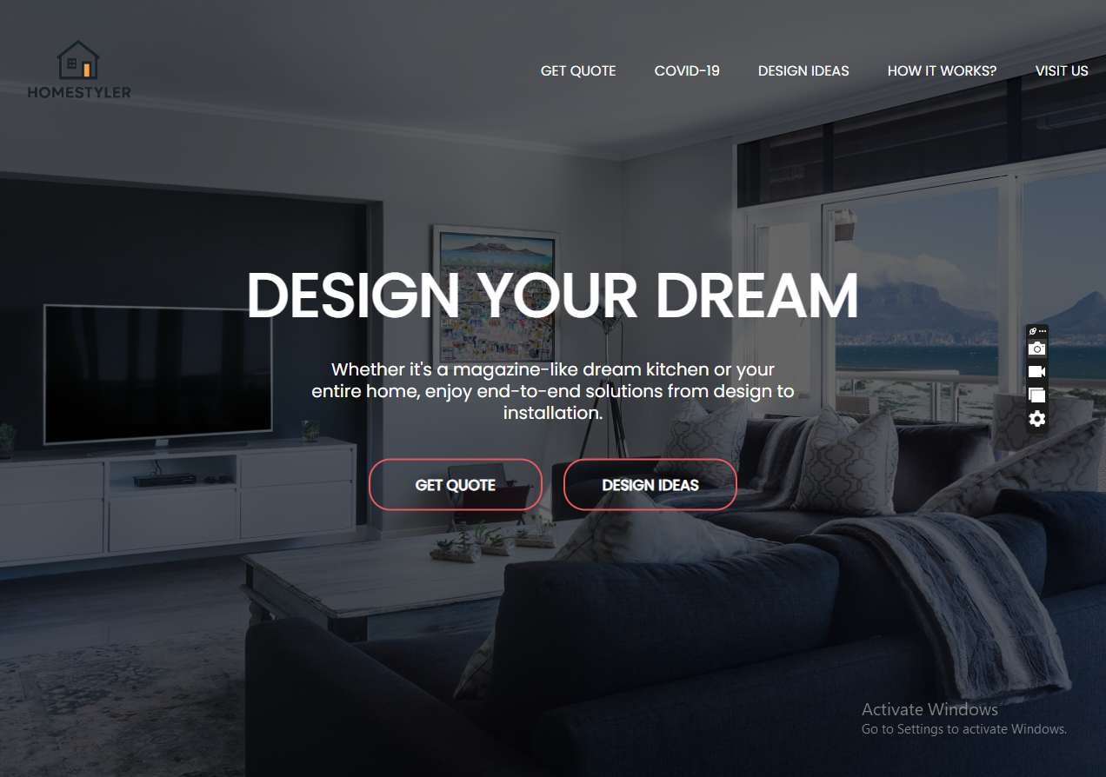**Home Page Screenshots**

**Get Qoute Page Screenshots**

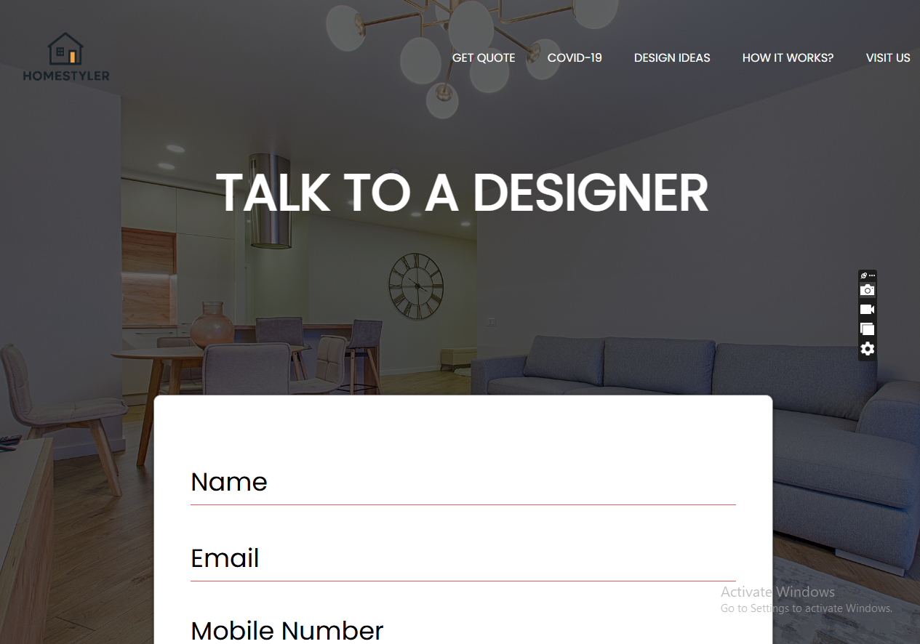

**Footer Page Screen Shots**

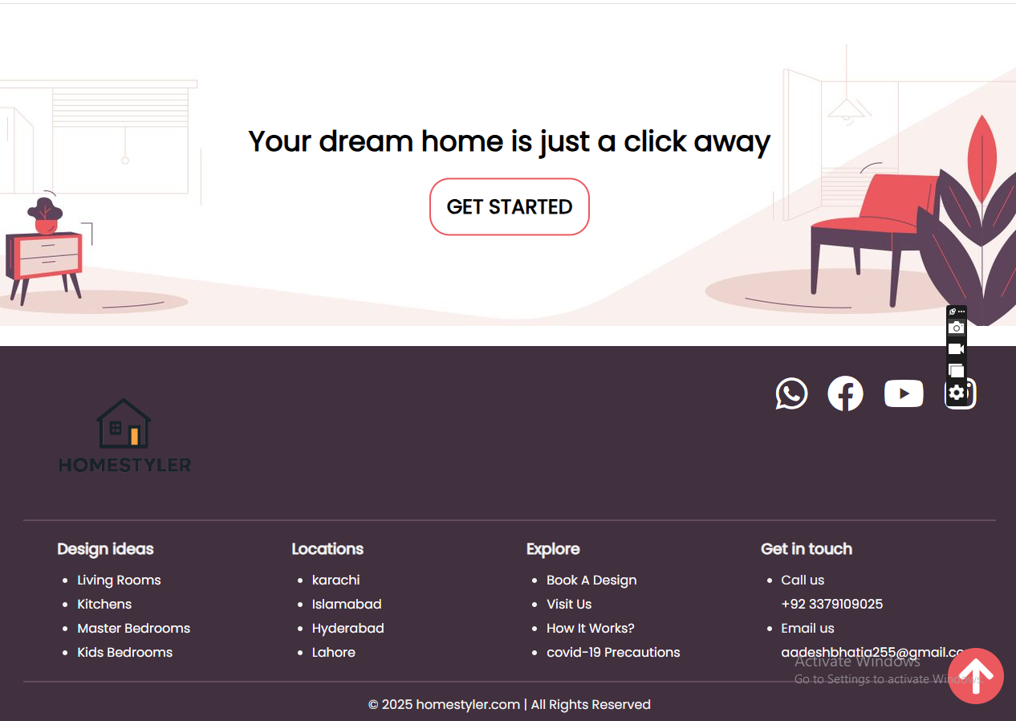

**Visit Page Screen Shot**



**Covid 19 shots**



**Design screen shots**

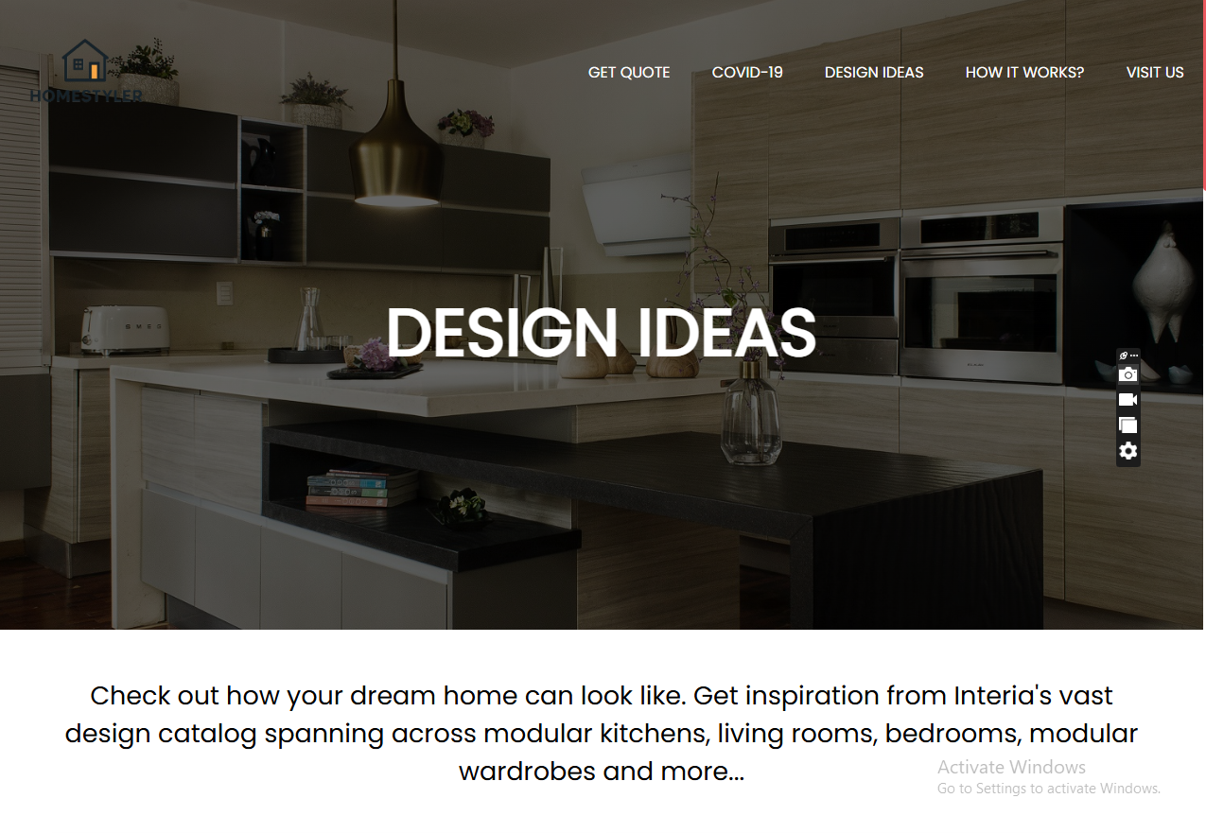

**Index Page Coding**

                <!DOCTYPE html>

<html lang="en">

<head>

    <meta charset="UTF-8">

    <meta http-equiv="X-UA-Compatible" content="IE=edge">

    <meta name="viewport" content="width=device-width, initial-scale=1.0">

    <!-- Font Awesome link -->

    <link rel="stylesheet"  href="https://cdnjs.cloudflare.com/ajax/libs/font-awesome/6.1.1/css/all.min.css">

    <!-- Style sheet -->

    <!-- <link rel="stylesheet" href="./css/style.css."> -->

    <link rel="stylesheet" href="../css/style.css">

    <title>Home</title>

</head>

<body>

    <!-- header section start -->

<header class="header">

    <a href="home.html" class="logo">I.IHandicraft</i></a>

    <form action="" class="search-form">

        <input type="search" placeholder="search" id="search-box">

        <label for="search-box" class="fas fa-search"></label>

    </form>

    <div class="icon">

      <div id="menu-btn" class="fas fa-bars"></div>

      <div id="search-btn" class="fas fa-search"></div>

      <div id="btn-cart" class="fas fa-cart-plus"></div>

      <div id="login-btn" class="fas fa-user"></div>

    </div>

</header>

<div id="closer" class="fas fa-times"></div>

<nav class="navbar">

<a href="home.html">Home</a>

<a href="shop.html">Handicraft Products</a>

<a href="about.html">About Us </a>

<a href="team.html">Team</a>

<a href="contact.html">Contact Info</a>

</nav>

<!-- Shopping cart section -->

<div class="shopping-cart">

    <div class="box">

        <i class="fa fa-times" aria-hidden="true"></i>

        <img src="./image/cart-img-1.jpg">

        <div class="content">

            <h3>Model Handicraft</h3>

            <span class="quantity">1</span>

            <span class="Multiply">x</span>

            <span class="price">$140</span>

        </div>

    </div>

    <div class="box">

        <i class="fa fa-times" aria-hidden="true"></i>

        <img src="./image/cart-img-2.jpg">

        <div class="content">

            <h3>Model Handicraft</h3>

            <span class="quantity"></span>

            <span class="Multiply"></span>

            <span class="price"></span>

        </div>

    </div>

    <div class="box">

        <i class="fa fa-times" aria-hidden="true"></i>

        <img src="./image/cart-img-3.jpg">

        <div class="content">

            <h3>Model Handicraft</h3>

            <span class="quantity"></span>

            <span class="Multiply"></span>

            <span class="price"></span>

        </div>

    </div>

    <div class="box">

        <i class="fa fa-times" aria-hidden="true"></i>

        <img src="./image/cart-img-4.jpg">

        <div class="content">

            <h3>Model Handicraft</h3>

            <span class="quantity"></span>

            <span class="Multiply"></span>

            <span class="price"></span>

        </div>

    </div>

    <h3 class="total">total : <span>560 </span></h3>

    <a href="#" class="btn">checkout cart</a>

</div>

<div class="login-form">

    <form action="" class="form">

    <h3>Lohin form</h3>

    <input type="email" placeholder="Enter Your eamil" class="box">

    <input type="password" placeholder="Enter your password" class="box">

    <div class="remember">

        <input type="checkbox" name="" id="remember-me">

        <label for="remember-me">remember</label>

    </div>

    <input type="submit" value="login now" class="btn">

    <p>Forgot password? <a href="#">click here</a></p>

    <p>dont have an account <a href="#">create now</a></p>

</form>

</div>

    <!-- home section start -->

<section class="home">

    <div class="slides-container">

        <div class="slide active">

            <div class="content">

                <span>New Arrival</span>

                <h3>Pakistan Handicraft</h3>

                <p>Lorem ipsum dolor sit amet consectetur adipisicing elit. Sunt autem, a consequatur deserunt et repellendus libero,.</p>

                <a href="#" class="btn">Shop now</a>

            </div>

            <div class="image">

                <img src="../handicrafts images/1.png" alt="">

            </div>

        </div>

        <div class="slide">

            <div class="content">

                <span>New Arrival</span>

                <h3>Pakistan Handicraft</h3>

                <p>Lorem ipsum dolor sit amet consectetur adipisicing elit. Sunt autem, a consequatur deserunt et repellendus libero,.</p>

                <a href="#" class="btn">Shop now</a>

            </div>

            <div class="image">

                <img src="../handicrafts images/2.png" alt="">

            </div>

        </div>

    </div>

    <div id="slide-next" onclick="next()" class="fas fa-angle-right"></div>

    <div id="slide-prev" onclick="prev()" class="fas fa-angle-left"></div>

</section>

     <!-- home section end -->

<!-- Banner section start -->

<div class="banner-container">

    <div class="banner">

        <img src="../handicrafts images/3.png" alt="">

        <div class="content">

            <span>Limited offer</span>

            <h3>upto 50% off</h3>

            <a href="#" class="btn"> shop now</a>

        </div>

    </div>

    <div class="banner">

        <img src="../handicrafts images/4.png" alt="">

        <div class="content">

            <span>Limited offer</span>

            <h3>upto 50% off</h3>

            <a href="#" class="btn"> shop now</a>

        </div>

    </div>

    <div class="banner">

        <img src="image/banner-3.jpg" alt="">

        <div class="content">

            <span>Limited offer</span>

            <h3>upto 50% off</h3>

            <a href="#" class="btn"> shop now</a>

        </div>

    </div>

</div>

<!-- Banner section end -->

<!-- footer section -->

<section class="footer">

<div class="box-container">

    <div class="box">

        <h3>Quick Link</h3>

        <a href="home.index"><i class="fas fa-arrow-right"></i> Home</a>

        <a href="shope.html"><i class="fas fa-arrow-right"></i> Handicraft Product</a>

        <a href="about.html"><i class="fas fa-arrow-right"></i> About</a>

        <a href="team.html"><i class="fas fa-arrow-right"></i> Team</a>

        <a href="contact.html"><i class="fas fa-arrow-right"></i> Contact Info</a>

    </div>

    <div class="box">

        <h3>Extra Link</h3>

        <a href="#"><i class="fab fa-arrow-right"></i> my order</a>

        <a href="#"><i class="fab fa-arrow-right"></i> my wishlist</a>

        <a href="#"><i class="fab fa-arrow-right"></i> my account</a>

        <a href=#"><i class="fab fa-arrow-right"></i> my favourite</a>

        <a href=#"><i class="fab fa-arrow-right"></i> term of users</a>

    </div>

    <div class="box">

        <h3>Extra Link</h3>

        <a href="#"><i class="fab fa-facebook-f"></i> Facebook</a>

        <a href="#"><i class="fab fa-twitter"></i> twitter</a>

        <a href="#"><i class="fab fa-instagram"></i> instagram</a>

        <a href="#"><i class="fab fa-linkedin"></i> linkedin</a>

        <a href="#"><i class="fab fa-pinterest"></i> pinterest</a>

    </div>

    <div class="box">

        <h3>news letter</h3>

        <p>subscribe for latest updates</p>

        <form action="">

            <input type="email" placeholder="enter your email" name="" id="">

            <input type="submit" class="btn" value="subscibe" name="" id="">

        </form>

    </div>

</div>

</section>

<section class="credit">

    created by Imtiaz Ali | all right reserved

</section>

<!-- footer section end -->

    <!-- java script files -->

    <script src="./script/script.js"></script>

</body>

</html>

QOUTE PAGE CODNG

<!DOCTYPE html>

<html lang="en">

<head>

    <meta charset="UTF-8">

    <meta http-equiv="X-UA-Compatible" content="IE=edge">

    <meta name="viewport" content="width=device-width, initial-scale=1.0">

    <!-- Font Awesome link -->

    <link rel="stylesheet"  href="https://cdnjs.cloudflare.com/ajax/libs/font-awesome/6.1.1/css/all.min.css">

    <!-- Style sheet -->

    <!-- <link rel="stylesheet" href="./css/style.css."> -->

    <link rel="stylesheet" href="../css/style.css">

    <title>Our Shop</title>

</head>

<body>

    <!-- header section start -->

<header class="header">

    <a href="home.html" class="logo">I.IHandicraft</i></a>

    <form action="" class="search-form">

        <input type="search" placeholder="search" id="search-box">

        <label for="search-box" class="fas fa-search"></label>

    </form>

    <div class="icon">

      <div id="menu-btn" class="fas fa-bars"></div>

      <div id="search-btn" class="fas fa-search"></div>

      <div id="btn-cart" class="fas fa-cart-plus"></div>

      <div id="login-btn" class="fas fa-user"></div>

    </div>

</header>

<div id="closer" class="fas fa-times"></div>

<nav class="navbar">

    <a href="home.html">Home</a>

    <a href="shop.html">Handicraft Products</a>

    <a href="about.html">About Us </a>

    <a href="team.html">Team</a>

    <a href="contact.html">Contact Info</a>

</nav>

<!-- Shopping cart section -->

<div class="shopping-cart">

    <div class="box">

        <i class="fa fa-times" aria-hidden="true"></i>

        <img src="./image/cart-img-1.jpg">

        <div class="content">

            <h3>Model Handicraft</h3>

            <span class="quantity">1</span>

            <span class="Multiply">x</span>

            <span class="price">$140</span>

        </div>

    </div>

    <div class="box">

        <i class="fa fa-times" aria-hidden="true"></i>

        <img src="./image/cart-img-2.jpg">

        <div class="content">

            <h3>Model Handicraft</h3>

            <span class="quantity"></span>

            <span class="Multiply"></span>

            <span class="price"></span>

        </div>

    </div>

    <div class="box">

        <i class="fa fa-times" aria-hidden="true"></i>

        <img src="./image/cart-img-3.jpg">

        <div class="content">

            <h3>Model Handicraft</h3>

            <span class="quantity"></span>

            <span class="Multiply"></span>

            <span class="price"></span>

        </div>

    </div>

    <div class="box">

        <i class="fa fa-times" aria-hidden="true"></i>

        <img src="./image/cart-img-4.jpg">

        <div class="content">

            <h3>Model Handicraft</h3>

            <span class="quantity"></span>

            <span class="Multiply"></span>

            <span class="price"></span>

        </div>

    </div>

    <h3 class="total">total : <span>560 </span></h3>

    <a href="#" class="btn">checkout cart</a>

</div>

<div class="login-form">

    <form action="" class="form">

    <h3>Lohin form</h3>

    <input type="email" placeholder="Enter Your eamil" class="box">

    <input type="password" placeholder="Enter your password" class="box">

    <div class="remember">

        <input type="checkbox" name="" id="remember-me">

        <label for="remember-me">remember</label>

    </div>

    <input type="submit" value="login now" class="btn">

    <p>Forgot password? <a href="#">click here</a></p>

    <p>dont have an account <a href="#">create now</a></p>

</form>

</div>

<section class="heading">

    <h3>Our Shop</h3>

    <p>

        <a href="home.html">home</a> / <span>Handicraft Product</span>

    </p>

</section>

<div class="category">

    <h1 class="title"> <span>our category</span> <a href="#">view all >></a> </h1>

    <div class="box-container">

        <a href="#" class="box">

            <img src="image/icon-1.png" alt="">

            <h3>House sofa</h3>

        </a>

        <a href="#" class="box">

            <img src="../handicrafts images/icon/i1.png" alt="">

            <h3>handicraft</h3>

        </a>

        <a href="#" class="box">

            <img src="../handicrafts images/icon/i2.png" alt="">

            <h3>handicraft</h3>

        </a>

        <a href="#" class="box">

            <img src="../handicrafts images/icon/i3.png" alt="">

            <h3>handicraft</h3>

        </a>

        <a href="#" class="box">

            <img src="../handicrafts images/icon/i4.png" alt="">

            <h3>handicraft</h3>

        </a>

    </div>

</div>

<section class="products">

    <h1 class="title"> <span>our products</span> <a href="#">view all >></a> </h1>

    <div class="box-container">

        <div class="box">

            <div class="icons">

                <a href="#" class="fas fa-shopping-cart"></a>

                <a href="#" class="fas fa-heart"></a>

                <a href="#" class="fas fa-eye"></a>

            </div>

            <div class="image">

                <img src="../handicrafts images/table.jpg" alt="">

            </div>

            <div class="content">

                <div class="price">$140.00</div>

                <h3>table</h3>

                <div class="stars">

                    <i class="fas fa-star"></i>

                    <i class="fas fa-star"></i>

                    <i class="fas fa-star"></i>

                    <i class="fas fa-star"></i>

                    <i class="far fa-star"></i>

                    <span> (50) </span>

                </div>

            </div>

        </div>

        <div class="box">

            <div class="icons">

                <a href="#" class="fas fa-shopping-cart"></a>

                <a href="#" class="fas fa-heart"></a>

                <a href="#" class="fas fa-eye"></a>

            </div>

            <div class="image">

                <img src="../handicrafts images/chair.jpg" alt="">

            </div>

            <div class="content">

                <div class="price">$140.00</div>

                <h3>Portable Chair</h3>

                <div class="stars">

                    <i class="fas fa-star"></i>

                    <i class="fas fa-star"></i>

                    <i class="fas fa-star"></i>

                    <i class="fas fa-star"></i>

                    <i class="far fa-star"></i>

                    <span> (50) </span>

                </div>

            </div>

        </div>

        <div class="box">

            <div class="icons">

                <a href="#" class="fas fa-shopping-cart"></a>

                <a href="#" class="fas fa-heart"></a>

                <a href="#" class="fas fa-eye"></a>

            </div>

            <div class="image">

                <img src="../handicrafts images/mirror.png" alt="">

            </div>

            <div class="content">

                <div class="price">$140.00</div>

                <h3>Wooden Mirror </h3>

                <div class="stars">

                    <i class="fas fa-star"></i>

                    <i class="fas fa-star"></i>

                    <i class="fas fa-star"></i>

                    <i class="fas fa-star"></i>

                    <i class="far fa-star"></i>

                    <span> (50) </span>

                </div>

            </div>

        </div>

        <div class="box">

            <div class="icons">

                <a href="#" class="fas fa-shopping-cart"></a>

                <a href="#" class="fas fa-heart"></a>

                <a href="#" class="fas fa-eye"></a>

            </div>

            <div class="image">

                <img src="../handicrafts images/marble clock.jpg" alt="">

            </div>

            <div class="content">

                <div class="price">$140.00</div>

                <h3>Marble Stylish Clock</h3>

                <div class="stars">

                    <i class="fas fa-star"></i>

                    <i class="fas fa-star"></i>

                    <i class="fas fa-star"></i>

                    <i class="fas fa-star"></i>

                    <i class="far fa-star"></i>

                    <span> (50) </span>

                </div>

            </div>

        </div>

        <div class="box">

            <div class="icons">

                <a href="#" class="fas fa-shopping-cart"></a>

                <a href="#" class="fas fa-heart"></a>

                <a href="#" class="fas fa-eye"></a>

            </div>

            <div class="image">

                <img src="../handicrafts images/marble jaar.jpg" alt="">

            </div>

            <div class="content">

                <div class="price">$140.00</div>

                <h3>Marble Stylish Jaar</h3>

                <div class="stars">

                    <i class="fas fa-star"></i>

                    <i class="fas fa-star"></i>

                    <i class="fas fa-star"></i>

                    <i class="fas fa-star"></i>

                    <i class="far fa-star"></i>

                    <span> (50) </span>

                </div>

            </div>

        </div>

        <div class="box">

            <div class="icons">

                <a href="#" class="fas fa-shopping-cart"></a>

                <a href="#" class="fas fa-heart"></a>

                <a href="#" class="fas fa-eye"></a>

            </div>

            <div class="image">

                <img src="../handicrafts images/marble gift piece.jpg" alt="">

            </div>

            <div class="content">

                <div class="price">$140.00</div>

                <h3>Marble stylish flame</h3>

                <div class="stars">

                    <i class="fas fa-star"></i>

                    <i class="fas fa-star"></i>

                    <i class="fas fa-star"></i>

                    <i class="fas fa-star"></i>

                    <i class="far fa-star"></i>

                    <span> (50) </span>

                </div>

            </div>

        </div>

        <div class="box">

            <div class="icons">

                <a href="#" class="fas fa-shopping-cart"></a>

                <a href="#" class="fas fa-heart"></a>

                <a href="#" class="fas fa-eye"></a>

            </div>

            <div class="image">

                <img src="../handicrafts images/lamp.jpg" alt="">

            </div>

            <div class="content">

                <div class="price">$140.00</div>

                <h3>Modern Lamp</h3>

                <div class="stars">

                    <i class="fas fa-star"></i>

                    <i class="fas fa-star"></i>

                    <i class="fas fa-star"></i>

                    <i class="fas fa-star"></i>

                    <i class="far fa-star"></i>

                    <span> (50) </span>

                </div>

            </div>

        </div>

        <div class="box">

            <div class="icons">

                <a href="#" class="fas fa-shopping-cart"></a>

                <a href="#" class="fas fa-heart"></a>

                <a href="#" class="fas fa-eye"></a>

            </div>

            <div class="image">

                <img src="../handicrafts images/handmade basket.jpg" alt="">

            </div>

            <div class="content">

                <div class="price">$140.00</div>

                <h3>hand made basket</h3>

                <div class="stars">

                    <i class="fas fa-star"></i>

                    <i class="fas fa-star"></i>

                    <i class="fas fa-star"></i>

                    <i class="fas fa-star"></i>

                    <i class="far fa-star"></i>

                    <span> (50) </span>

                </div>

            </div>

        </div>

    </div>

</section>

<!-- footer section -->

<section class="footer">

<div class="box-container">

    <div class="box">

        <h3>Quick Link</h3>

        <a href="home.index"><i class="fas fa-arrow-right"></i> Home</a>

        <a href="shope.html"><i class="fas fa-arrow-right"></i> Handicrafts Products</a>

        <a href="about.html"><i class="fas fa-arrow-right"></i> About Us</a>

        <a href="team.html"><i class="fas fa-arrow-right"></i> Team</a>

        <a href="contact.html"><i class="fas fa-arrow-right"></i> Contact info</a>

    </div>

    <div class="box">

        <h3>Extra Link</h3>

        <a href="#"><i class="fab fa-arrow-right"></i> my order</a>

        <a href="#"><i class="fab fa-arrow-right"></i> my wishlist</a>

        <a href="#"><i class="fab fa-arrow-right"></i> my account</a>

        <a href=#"><i class="fab fa-arrow-right"></i> my favourite</a>

        <a href=#"><i class="fab fa-arrow-right"></i> term of users</a>

    </div>

    <div class="box">

        <h3>Extra Link</h3>

        <a href="#"><i class="fab fa-facebook-f"></i> Facebook</a>

        <a href="#"><i class="fab fa-twitter"></i> twitter</a>

        <a href="#"><i class="fab fa-instagram"></i> instagram</a>

        <a href="#"><i class="fab fa-linkedin"></i> linkedin</a>

        <a href="#"><i class="fab fa-pinterest"></i> pinterest</a>

    </div>

    <div class="box">

        <h3>news letter</h3>

        <p>subscribe for latest updates</p>

        <form action="">

            <input type="email" placeholder="enter your email" name="" id="">

            <input type="submit" class="btn" value="subscibe" name="" id="">

        </form>

    </div>

</div>

</section>

<section class="credit">

    created by Imtiaz Ali | all right reserved

</section>

<!-- footer section end -->

    <!-- java script files -->

    <script src="./script/script.js"></script>

</body>

</html>

VISIT US Us Coding

<!DOCTYPE html>

<html lang="en">

<head>

    <meta charset="UTF-8">

    <meta http-equiv="X-UA-Compatible" content="IE=edge">

    <meta name="viewport" content="width=device-width, initial-scale=1.0">

    <!-- Font Awesome link -->

    <link rel="stylesheet"  href="https://cdnjs.cloudflare.com/ajax/libs/font-awesome/6.1.1/css/all.min.css">

    <!-- Style sheet -->

    <!-- <link rel="stylesheet" href="./css/style.css."> -->

    <link rel="stylesheet" href="../css/style.css">

    <title>About us</title>

</head>

<body>

    <!-- header section start -->

<header class="header">

    <a href="home.html" class="logo">I.IHandicraft</i></a>

    <form action="" class="search-form">

        <input type="search" placeholder="search" id="search-box">

        <label for="search-box" class="fas fa-search"></label>

    </form>

    <div class="icon">

      <div id="menu-btn" class="fas fa-bars"></div>

      <div id="search-btn" class="fas fa-search"></div>

      <div id="btn-cart" class="fas fa-cart-plus"></div>

      <div id="login-btn" class="fas fa-user"></div>

    </div>

</header>

<div id="closer" class="fas fa-times"></div>

<nav class="navbar">

<a href="./home.html">Home</a>

<a href="./shop.html">Shop</a>

<a href="./shop.html">About</a>

<a href="./team.html">Team</a>

<a href="./about.html">Contact</a>

</nav>

<!-- Shopping cart section -->

<div class="shopping-cart">

    <div class="box">

        <i class="fa fa-times" aria-hidden="true"></i>

        <img src="./image/cart-img-1.jpg">

        <div class="content">

            <h3>Model Handicraft</h3>

            <span class="quantity">1</span>

            <span class="Multiply">x</span>

            <span class="price">$140</span>

        </div>

    </div>

    <div class="box">

        <i class="fa fa-times" aria-hidden="true"></i>

        <img src="./image/cart-img-2.jpg">

        <div class="content">

            <h3>Model Handicraft</h3>

            <span class="quantity"></span>

            <span class="Multiply"></span>

            <span class="price"></span>

        </div>

    </div>

    <div class="box">

        <i class="fa fa-times" aria-hidden="true"></i>

        <img src="./image/cart-img-3.jpg">

        <div class="content">

            <h3>Model Handicraft</h3>

            <span class="quantity"></span>

            <span class="Multiply"></span>

            <span class="price"></span>

        </div>

    </div>

    <div class="box">

        <i class="fa fa-times" aria-hidden="true"></i>

        <img src="./image/cart-img-4.jpg">

        <div class="content">

            <h3>Model Handicraft</h3>

            <span class="quantity"></span>

            <span class="Multiply"></span>

            <span class="price"></span>

        </div>

    </div>

    <h3 class="total">total : <span>560 </span></h3>

    <a href="#" class="btn">checkout cart</a>

</div>

<div class="login-form">

    <form action="" class="form">

    <h3>Login form</h3>

    <input type="email" placeholder="Enter Your eamil" class="box">

    <input type="password" placeholder="Enter your password" class="box">

    <div class="remember">

        <input type="checkbox" name="" id="remember-me">

        <label for="remember-me">remember</label>

    </div>

    <input type="submit" value="login now" class="btn">

    <p>Forgot password? <a href="#">click here</a></p>

    <p>dont have an account <a href="#">create now</a></p>

</form>

</div>

<section class="heading">

    <h3>about us</h3>

    <p> <a href="home.html">home</a> / <span>about</span> </p>

</section>

<section class="about">

    <div class="image">

        <img src="image/about-img.jpg" alt="">

    </div>

    <div class="content">

        <span>welcome to our shop</span>

        <h3>we make your home more astonishing</h3>

        <p>Lorem ipsum dolor sit amet consectetur adipisicing elit. Ullam officiis, reiciendis veniam incidunt architecto quam velit dolorum exercitationem cum aliquam ab quas dicta dolores ad earum quasis.</p>

        <p>Lorem ipsum dolor sit amet consectetur adipisicing elit. Sapiente adipisci totam, nam voluptates quis delectus. Ea quo repudiandae.</p>

        <a href="#" class="btn">read more</a>

    </div>

</section>

<section class="services">

    <h1 class="title"> <span>our services</span> <a href="#">view all >></a> </h1>

    <div class="box-container">

        <div class="box">

            <img src="image/serv-1.svg" alt="">

            <h3>product selling</h3>

            <p>Lorem ipsum dolor sit amet consectetur adipisicing elit. Voluptates, quod.</p>

            <a href="#" class="btn">read more</a>

        </div>

        <div class="box">

            <img src="image/serv-2.svg" alt="">

            <h3>product designing</h3>

            <p>Lorem ipsum dolor sit amet consectetur adipisicing elit. Voluptates, quod.</p>

            <a href="#" class="btn">read more</a>

        </div>

        <div class="box">

            <img src="image/serv-3.svg" alt="">

            <h3>24 / 7 support</h3>

            <p>Lorem ipsum dolor sit amet consectetur adipisicing elit. Voluptates, quod.</p>

            <a href="#" class="btn">read more</a>

        </div>

    </div>

</section>

<!-- footer section -->

<section class="footer">

<div class="box-container">

    <div class="box">

        <h3>Quick Link</h3>

        <a href="home.index"><i class="fas fa-arrow-right"></i> Home</a>

        <a href="shope.html"><i class="fas fa-arrow-right"></i> Handicraft Product</a>

        <a href="about.html"><i class="fas fa-arrow-right"></i> About</a>

        <a href="team.html"><i class="fas fa-arrow-right"></i> Team</a>

        <a href="contact.html"><i class="fas fa-arrow-right"></i> Contact Info</a>

    </div>

    <div class="box">

        <h3>Extra Link</h3>

        <a href="#"><i class="fab fa-arrow-right"></i> my order</a>

        <a href="#"><i class="fab fa-arrow-right"></i> my wishlist</a>

        <a href="#"><i class="fab fa-arrow-right"></i> my account</a>

        <a href=#"><i class="fab fa-arrow-right"></i> my favourite</a>

        <a href=#"><i class="fab fa-arrow-right"></i> term of users</a>

    </div>

    <div class="box">

        <h3>Extra Link</h3>

        <a href="#"><i class="fab fa-facebook-f"></i> Facebook</a>

        <a href="#"><i class="fab fa-twitter"></i> twitter</a>

        <a href="#"><i class="fab fa-instagram"></i> instagram</a>

        <a href="#"><i class="fab fa-linkedin"></i> linkedin</a>

        <a href="#"><i class="fab fa-pinterest"></i> pinterest</a>

    </div>

    <div class="box">

        <h3>news letter</h3>

        <p>subscribe for latest updates</p>

        <form action="">

            <input type="email" placeholder="enter your email" name="" id="">

            <input type="submit" class="btn" value="subscibe" name="" id="">

        </form>

    </div>

</div>

</section>

<section class="credit">

    created by Imtiaz Ali | all right reserved

</section>

<!-- footer section end -->

    <!-- java script files -->

    <script src="./script/script.js"></script>

</body>

</html>

COVID-19 Page Coding

<!DOCTYPE html>

<html lang="en">

<head>

    <meta charset="UTF-8">

    <meta http-equiv="X-UA-Compatible" content="IE=edge">

    <meta name="viewport" content="width=device-width, initial-scale=1.0">

    <!-- Font Awesome link -->

    <link rel="stylesheet"  href="https://cdnjs.cloudflare.com/ajax/libs/font-awesome/6.1.1/css/all.min.css">

    <!-- Style sheet -->

    <!-- <link rel="stylesheet" href="./css/style.css."> -->

    <link rel="stylesheet" href="../css/style.css">

    <title>Our Team</title>

</head>

<body>

    <!-- header section start -->

<header class="header">

    <a href="home.html" class="logo">I.IHandicraft</i></a>

    <form action="" class="search-form">

        <input type="search" placeholder="search" id="search-box">

        <label for="search-box" class="fas fa-search"></label>

    </form>

    <div class="icon">

      <div id="menu-btn" class="fas fa-bars"></div>

      <div id="search-btn" class="fas fa-search"></div>

      <div id="btn-cart" class="fas fa-cart-plus"></div>

      <div id="login-btn" class="fas fa-user"></div>

    </div>

</header>

<div id="closer" class="fas fa-times"></div>

<nav class="navbar">

<a href="./home.html">Home</a>

<a href="./shop.html">Handicraft Product</a>

<a href="./about.html">About</a>

<a href="./team.html">Team</a>

<a href="./contact.html">Contact  Info </a>

</nav>

<!-- Shopping cart section -->

<div class="shopping-cart">

    <div class="box">

        <i class="fa fa-times" aria-hidden="true"></i>

        <img src="./image/cart-img-1.jpg">

        <div class="content">

            <h3>Model Handicraft</h3>

            <span class="quantity">1</span>

            <span class="Multiply">x</span>

            <span class="price">$140</span>

        </div>

    </div>

    <div class="box">

        <i class="fa fa-times" aria-hidden="true"></i>

        <img src="./image/cart-img-2.jpg">

        <div class="content">

            <h3>Model Handicraft</h3>

            <span class="quantity"></span>

            <span class="Multiply"></span>

            <span class="price"></span>

        </div>

    </div>

    <div class="box">

        <i class="fa fa-times" aria-hidden="true"></i>

        <img src="./image/cart-img-3.jpg">

        <div class="content">

            <h3>Model Handicraft</h3>

            <span class="quantity"></span>

            <span class="Multiply"></span>

            <span class="price"></span>

        </div>

    </div>

    <div class="box">

        <i class="fa fa-times" aria-hidden="true"></i>

        <img src="./image/cart-img-4.jpg">

        <div class="content">

            <h3>Model Handicraft</h3>

            <span class="quantity"></span>

            <span class="Multiply"></span>

            <span class="price"></span>

        </div>

    </div>

    <h3 class="total">total : <span>560 </span></h3>

    <a href="#" class="btn">checkout cart</a>

</div>

<div class="login-form">

    <form action="" class="form">

    <h3>Login form</h3>

    <input type="email" placeholder="Enter Your eamil" class="box">

    <input type="password" placeholder="Enter your password" class="box">

    <div class="remember">

        <input type="checkbox" name="" id="remember-me">

        <label for="remember-me">remember</label>

    </div>

    <input type="submit" value="login now" class="btn">

    <p>Forgot password? <a href="#">click here</a></p>

    <p>dont have an account <a href="#">create now</a></p>

</form>

</div>

<section class="team">

    <h1 class="title"> <span>our team</span> <a href="#">view all >></a> </h1>

    <div class="box-container">

        <div class="box">

            <div class="share">

                <a href="#" class="fab fa-facebook-f"></a>

                <a href="#" class="fab fa-twitter"></a>

                <a href="#" class="fab fa-pinterest"></a>

                <a href="#" class="fab fa-instagram"></a>

            </div>

            <div class="image">

                <img src="../handicrafts images/imtiaz.jpg" alt="">

            </div>

            <div class="user">

                <h3>Imtiaz Ali</h3>

                <span>CEO </span>

            </div>

        </div>

        <div class="box">

            <div class="share">

                <a href="#" class="fab fa-facebook-f"></a>

                <a href="#" class="fab fa-twitter"></a>

                <a href="#" class="fab fa-pinterest"></a>

                <a href="#" class="fab fa-instagram"></a>

            </div>

            <div class="image">

                <img src="../handicrafts images/mutahir.jpg" alt="">

            </div>

            <div class="user">

                <h3>Mutahir</h3>

                <span>Developer</span>

            </div>

        </div>

        <div class="box">

            <div class="share">

                <a href="#" class="fab fa-facebook-f"></a>

                <a href="#" class="fab fa-twitter"></a>

                <a href="#" class="fab fa-pinterest"></a>

                <a href="#" class="fab fa-instagram"></a>

            </div>

            <div class="image">

                <img src="../handicrafts images/yaseen.jpeg" alt="">

            </div>

            <div class="user">

                <h3>Yaseen</h3>

                <span>designer</span>

            </div>

        </div>

        <!-- <div class="box">

            <div class="share">

                <a href="#" class="fab fa-facebook-f"></a>

                <a href="#" class="fab fa-twitter"></a>

                <a href="#" class="fab fa-pinterest"></a>

                <a href="#" class="fab fa-instagram"></a>

            </div>

            <div class="image">

                <img src="image/team-4.jpg" alt="">

            </div>

            <div class="user">

                <h3>john deo</h3>

                <span>designer</span>

            </div>

        </div> -->

<!--

        <div class="box">

            <div class="share">

                <a href="#" class="fab fa-facebook-f"></a>

                <a href="#" class="fab fa-twitter"></a>

                <a href="#" class="fab fa-pinterest"></a>

                <a href="#" class="fab fa-instagram"></a>

            </div>

            <div class="image">

                <img src="image/team-5.jpg" alt="">

            </div>

            <div class="user">

                <h3>john deo</h3>

                <span>designer</span>

            </div>

        </div> -->

        <!-- <div class="box">

            <div class="share">

                <a href="#" class="fab fa-facebook-f"></a>

                <a href="#" class="fab fa-twitter"></a>

                <a href="#" class="fab fa-pinterest"></a>

                <a href="#" class="fab fa-instagram"></a>

            </div>

            <div class="image">

                <img src="image/team-6.jpg" alt="">

            </div>

            <div class="user">

                <h3>john deo</h3>

                <span>designer</span>

            </div>

        </div> -->

    </div>

</section>

<!-- footer section -->

<section class="footer">

<div class="box-container">

    <div class="box">

        <h3>Quick Link</h3>

        <a href="home.index"><i class="fas fa-arrow-right"></i> Home</a>

        <a href="shope.html"><i class="fas fa-arrow-right"></i> Handicraft Product</a>

        <a href="about.html"><i class="fas fa-arrow-right"></i> About Us </a>

        <a href="team.html"><i class="fas fa-arrow-right"></i> Team</a>

        <a href="contact.html"><i class="fas fa-arrow-right"></i> Contact Info </a>

    </div>

    <div class="box">

        <h3>Extra Link</h3>

        <a href="#"><i class="fab fa-arrow-right"></i> my order</a>

        <a href="#"><i class="fab fa-arrow-right"></i> my wishlist</a>

        <a href="#"><i class="fab fa-arrow-right"></i> my account</a>

        <a href=#"><i class="fab fa-arrow-right"></i> my favourite</a>

        <a href=#"><i class="fab fa-arrow-right"></i> term of users</a>

    </div>

    <div class="box">

        <h3>Extra Link</h3>

        <a href="#"><i class="fab fa-facebook-f"></i> Facebook</a>

        <a href="#"><i class="fab fa-twitter"></i> twitter</a>

        <a href="#"><i class="fab fa-instagram"></i> instagram</a>

        <a href="#"><i class="fab fa-linkedin"></i> linkedin</a>

        <a href="#"><i class="fab fa-pinterest"></i> pinterest</a>

    </div>

    <div class="box">

        <h3>news letter</h3>

        <p>subscribe for latest updates</p>

        <form action="">

            <input type="email" placeholder="enter your email" name="" id="">

            <input type="submit" class="btn" value="subscibe" name="" id="">

        </form>

    </div>

</div>

</section>

<section class="credit">

    created by Imtiaz Ali | all right reserved

</section>

<!-- footer section end -->

    <!-- java script files -->

    <script src="./script/script.js"></script>

</body>

</html>

DESIGN Page Coding

<!DOCTYPE html>

<html lang="en">

<head>

    <meta charset="UTF-8">

    <meta http-equiv="X-UA-Compatible" content="IE=edge">

    <meta name="viewport" content="width=device-width, initial-scale=1.0">

    <!-- Font Awesome link -->

    <link rel="stylesheet"  href="https://cdnjs.cloudflare.com/ajax/libs/font-awesome/6.1.1/css/all.min.css">

    <!-- Style sheet -->

    <!-- <link rel="stylesheet" href="./css/style.css."> -->

    <link rel="stylesheet" href="../css/style.css">

    <title>Contact Us</title>

</head>

<body>

    <!-- header section start -->

<header class="header">

    <a href="home.html" class="logo">I.IHandicraft</i></a>

    <form action="" class="search-form">

        <input type="search" placeholder="search" id="search-box">

        <label for="search-box" class="fas fa-search"></label>

    </form>

    <div class="icon">

      <div id="menu-btn" class="fas fa-bars"></div>

      <div id="search-btn" class="fas fa-search"></div>

      <div id="btn-cart" class="fas fa-cart-plus"></div>

      <div id="login-btn" class="fas fa-user"></div>

    </div>

</header>

<div id="closer" class="fas fa-times"></div>

<nav class="navbar">

    <a href="home.html">Home</a>

    <a href="shop.html">Handicraft Products</a>

    <a href="about.html">About Us </a>

    <a href="team.html">Team</a>

    <a href="contact.html">Contact Info</a>

</nav>

<!-- Shopping cart section -->

<div class="shopping-cart">

    <div class="box">

        <i class="fa fa-times" aria-hidden="true"></i>

        <img src="../handicrafts images/1.png">

        <div class="content">

            <h3>Model Handicraft</h3>

            <span class="quantity">1</span>

            <span class="Multiply">x</span>

            <span class="price">$140</span>

        </div>

    </div>

    <div class="box">

        <i class="fa fa-times" aria-hidden="true"></i>

        <img src="../handicrafts images/2.png">

        <div class="content">

            <h3>Model Handicraft</h3>

            <span class="quantity"></span>

            <span class="Multiply"></span>

            <span class="price"></span>

        </div>

    </div>

    <div class="box">

        <i class="fa fa-times" aria-hidden="true"></i>

        <img src="../handicrafts images/3.png">

        <div class="content">

            <h3>Model Handicraft</h3>

            <span class="quantity"></span>

            <span class="Multiply"></span>

            <span class="price"></span>

        </div>

    </div>

    <div class="box">

        <i class="fa fa-times" aria-hidden="true"></i>

        <img src="../handicrafts images/4.png">

        <div class="content">

            <h3>Model Handicraft</h3>

            <span class="quantity"></span>

            <span class="Multiply"></span>

            <span class="price"></span>

        </div>

    </div>

    <h3 class="total">total : <span>560 </span></h3>

    <a href="#" class="btn">checkout cart</a>

</div>

<div class="login-form">

    <form action="" class="form">

    <h3>Lohin form</h3>

    <input type="email" placeholder="Enter Your eamil" class="box">

    <input type="password" placeholder="Enter your password" class="box">

    <div class="remember">

        <input type="checkbox" name="" id="remember-me">

        <label for="remember-me">remember</label>

    </div>

    <input type="submit" value="login now" class="btn">

    <p>Forgot password? <a href="#">click here</a></p>

    <p>dont have an account <a href="#">create now</a></p>

</form>

</div>

<section class="heading">

    <h3>contact us</h3>

    <p> <a href="home.html">home</a> / <span>contact</span> </p>

</section>

<div class="contact">

    <form action="">

        <h3>get in touch</h3>

        <span>your name</span>

        <input type="text" class="box">

        <span>your number</span>

        <input type="number" class="box">

        <span>your email</span>

        <input type="email" class="box">

        <span>your message</span>

        <textarea class="box" name="" id="" cols="30" rows="10"></textarea>

        <input type="submit" value="send message" class="btn">

    </form>

    <!-- <iframe class="map" src="https://www.google.com/maps/embed?pb=!1m18!1m12!1m3!1d30153.788252261566!2d72.82321484621745!3d19.141690214227783!2m3!1f0!2f0!3f0!3m2!1i1024!2i768!4f13.1!3m3!1m2!1s0x3be7b63aceef0c69%3A0x2aa80cf2287dfa3b!2sJogeshwari%20West%2C%20Mumbai%2C%20Maharashtra%20400047!5e0!3m2!1sen!2sin!4v1634314289650!5m2!1sen!2sin" allowfullscreen="" loading="lazy"></iframe> -->

    <iframe class="map"src="https://www.google.com/maps/embed?pb=!1m18!1m12!1m3!1d3604.5196171378543!2d68.36162016475771!3d25.387411630187657!2m3!1f0!2f0!3f0!3m2!1i1024!2i768!4f13.1!3m3!1m2!1s0x394c70ee760a28e3%3A0x237431113a093222!2sSaddar%2C%20Hyderabad%2C%20Sindh%2C%20Pakistan!5e0!3m2!1sen!2s!4v1649167759263!5m2!1sen!2s" width="600" allowfullscreen="" loading="lazy" referrerpolicy="no-referrer-when-downgrade"></iframe>

</div>

<!-- footer section -->

<section class="footer">

<div class="box-container">

    <div class="box">

        <h3>Quick Link</h3>

        <a href="home.index"><i class="fas fa-arrow-right"></i> Home</a>

        <a href="shope.html"><i class="fas fa-arrow-right"></i> Shop</a>

        <a href="about.html"><i class="fas fa-arrow-right"></i> About</a>

        <a href="team.html"><i class="fas fa-arrow-right"></i> Team</a>

        <a href="blog.html"><i class="fas fa-arrow-right"></i> Blog</a>

        <a href="contact.html"><i class="fas fa-arrow-right"></i> Contact</a>

    </div>

    <div class="box">

        <h3>Extra Link</h3>

        <a href="#"><i class="fab fa-arrow-right"></i> my order</a>

        <a href="#"><i class="fab fa-arrow-right"></i> my wishlist</a>

        <a href="#"><i class="fab fa-arrow-right"></i> my account</a>

        <a href=#"><i class="fab fa-arrow-right"></i> my favourite</a>

        <a href=#"><i class="fab fa-arrow-right"></i> term of users</a>

    </div>

    <div class="box">

        <h3>Extra Link</h3>

        <a href="#"><i class="fab fa-facebook-f"></i> Facebook</a>

        <a href="#"><i class="fab fa-twitter"></i> twitter</a>

        <a href="#"><i class="fab fa-instagram"></i> instagram</a>

        <a href="#"><i class="fab fa-linkedin"></i> linkedin</a>

        <a href="#"><i class="fab fa-pinterest"></i> pinterest</a>

    </div>

    <div class="box">

        <h3>news letter</h3>

        <p>subscribe for latest updates</p>

        <form action="">

            <input type="email" placeholder="enter your email" name="" id="">

            <input type="submit" class="btn" value="subscibe" name="" id="">

        </form>

    </div>

</div>

</section>

<section class="credit">

    created by Imtiaz Ali | all right reserved

</section>

<!-- footer section end -->

    <!-- java script files -->

    <script src="./script/script.js"></script>

</body>

</html>

CSS FILE CODING

 @import url("https://fonts.googleapis.com/css2?family=Poppins:wght@100;300;400;500;600&display=swap");

* {

  font-family: 'Poppins', sans-serif;

  margin: 0;

  padding: 0;

  -webkit-box-sizing: border-box;

          box-sizing: border-box;

  outline: none;

  border: none;

  text-decoration: none;

  text-transform: capitalize;

  -webkit-transition: .2s linear;

  transition: .2s linear;

}

html {

  font-size: 62.5%;

  overflow-x: hidden;

}

html::-webkit-scrollbar {

  width: 1rem;

}

html::-webkit-scrollbar-track {

  background: #fff;

}

html::-webkit-scrollbar-thumb {

  background: #244d4d;

}

section {

  padding: 3rem 9%;

}

.heading {

  background: #244d4d;

  display: -webkit-box;

  display: -ms-flexbox;

  display: flex;

  -webkit-box-align: center;

      -ms-flex-align: center;

          align-items: center;

  -webkit-box-pack: justify;

      -ms-flex-pack: justify;

          justify-content: space-between;

  padding-top: 5rem;

  padding-bottom: 5rem;

}

.heading h3 {

  font-size: 2.5rem;

  text-transform: uppercase;

  color: #fff;

}

.heading p {

  color: #fff;

  font-size: 2rem;

}

.heading p span {

  color: yellow;

}

.heading p a {

  color: #fff;

}

.heading p a:hover {

  color: yellow;

}

.title {

  display: -webkit-box;

  display: -ms-flexbox;

  display: flex;

  -webkit-box-align: center;

      -ms-flex-align: center;

          align-items: center;

  -webkit-box-pack: justify;

      -ms-flex-pack: justify;

          justify-content: space-between;

  margin-bottom: 3rem;

  border-bottom: 0.1rem solid #244d4d;

  padding-bottom: 1.5rem;

}

.title span {

  font-size: 2.5rem;

  color: #244d4d;

}

.title a {

  font-size: 1.5rem;

  color: #779;

}

.title a:hover {

  color: #244d4d;

}

.btn {

  display: inline-block;

  margin-top: 1rem;

  padding: .9rem 3rem;

  font-size: 1.7rem;

  background: #244d4d;

  color: #fff;

  cursor: pointer;

}

.btn:hover {

  background: #316868;

}

.header {

  padding: 2rem 9%;

  position: -webkit-sticky;

  position: sticky;

  top: 0;

  left: 0;

  right: 0;

  z-index: 100;

  background: #f6fbf6;

  display: -webkit-box;

  display: -ms-flexbox;

  display: flex;

  -webkit-box-align: center;

      -ms-flex-align: center;

          align-items: center;

  -webkit-box-pack: justify;

      -ms-flex-pack: justify;

          justify-content: space-between;

}

.header .logo {

  font-size: 2.5rem;

  color: #244d4d;

  font-weight: bolder;

}

.header .logo i {

  padding-right: .3rem;

}

.header .search-form {

  height: 5rem;

  width: 50rem;

  border-radius: 5rem;

  background: #fff;

  overflow: hidden;

  display: -webkit-box;

  display: -ms-flexbox;

  display: flex;

  -webkit-box-align: center;

      -ms-flex-align: center;

          align-items: center;

  border: 0.1rem solid #244d4d;

}

.header .search-form input {

  height: 100%;

  width: 100%;

  padding: 0 1.2rem;

  font-size: 1.6rem;

  color: #244d4d;

  text-transform: none;

}

.header .search-form label {

  font-size: 2.2rem;

  padding-right: 1.7rem;

  cursor: pointer;

  color: #244d4d;

}

.header .search-form label:hover {

  color: #779;

}

.icon div{

  margin-left: 2rem;

  font-size: 2.5rem;

  cursor: pointer;

  color:#244d4d;

}

.icon div:hover{

  color: #779;

}

#search-btn {

  display: none;

}

@-webkit-keyframes rotate {

  0% {

    -webkit-transform: rotate(360deg);

            transform: rotate(360deg);

    opacity: 0;

  }

}

@keyframes rotate {

  0% {

    -webkit-transform: rotate(360deg);

            transform: rotate(360deg);

    opacity: 0;

  }

}

#closer {

  position: fixed;

  top: 1.5rem;

  right: 2rem;

  font-size: 5rem;

  cursor: pointer;

  z-index: 10000;

  color: #244d4d;

  -webkit-animation: rotate .4s linear .4s backwards;

          animation: rotate .4s linear .4s backwards;

  display: none;

}

#closer:hover {

  color: #779;

}

.navbar {

  position: fixed;

  top: 0;

  right: -101%;

  z-index: 1000;

  width: 35rem;

  height: 100vh;

  background: #fff;

  display: -webkit-box;

  display: -ms-flexbox;

  display: flex;

  -webkit-box-align: center;

      -ms-flex-align: center;

          align-items: center;

  -webkit-box-pack: center;

      -ms-flex-pack: center;

          justify-content: center;

  -webkit-box-orient: vertical;

  -webkit-box-direction: normal;

      -ms-flex-flow: column;

          flex-flow: column;

}

.navbar.active {

  right: 0;

  -webkit-box-shadow: 0 0 0 100vw rgba(0, 0, 0, 0.5);

          box-shadow: 0 0 0 100vw rgba(0, 0, 0, 0.5);

  -webkit-transition: .4s linear;

  transition: .4s linear;

}

.navbar a {

  margin: 1rem 0;

  font-size: 2.5rem;

  color: #244d4d;

}

.navbar a:hover {

  color: #779;

}

.shopping-cart {

  position: fixed;

  top: 0;

  right: -101%;

  z-index: 1000;

  width: 35rem;

  height: 100vh;

  background: #fff;

  padding: 2rem;

  padding-top: 8rem;

  overflow-y: scroll;

}

.shopping-cart.active {

  right: 0;

  -webkit-box-shadow: 0 0 0 100vw rgba(0, 0, 0, 0.5);

          box-shadow: 0 0 0 100vw rgba(0, 0, 0, 0.5);

  -webkit-transition: .4s linear;

  transition: .4s linear;

}

.shopping-cart::-webkit-scrollbar {

  width: 1rem;

}

.shopping-cart::-webkit-scrollbar-track {

  background: #fff;

}

.shopping-cart::-webkit-scrollbar-thumb {

  background: #244d4d;

}

.shopping-cart .box {

  display: -webkit-box;

  display: -ms-flexbox;

  display: flex;

  -webkit-box-align: center;

      -ms-flex-align: center;

          align-items: center;

  gap: 1.5rem;

  position: relative;

  margin-bottom: 1rem;

}

.shopping-cart .box .fa-times {

  position: absolute;

  top: 50%;

  right: 1rem;

  -webkit-transform: translateY(-50%);

          transform: translateY(-50%);

  font-size: 2rem;

  color: #779;

  cursor: pointer;

}

.shopping-cart .box .fa-times:hover {

  color: #244d4d;

}

.shopping-cart .box img {

  height: 8rem;

}

.shopping-cart .box .content h3 {

  color: #244d4d;

  font-size: 1.8rem;

  padding-bottom: .5rem;

}

.shopping-cart .box .content span {

  font-size: 1.5rem;

  color: #779;

}

.shopping-cart .box .content span.multipy {

  margin: 0 1rem;

}

.shopping-cart .total {

  text-align: center;

  font-size: 2rem;

  padding: 1rem 0;

  color: #779;

}

.shopping-cart .total span {

  color: #244d4d;

}

.shopping-cart .btn {

  width: 100%;

  text-align: center;

}

.login-form {

  position: fixed;

  top: 0;

  right: -101%;

  z-index: 1000;

  width: 35rem;

  height: 100vh;

  background: #fff;

  padding: 2rem;

  display: -webkit-box;

  display: -ms-flexbox;

  display: flex;

  -webkit-box-align: center;

      -ms-flex-align: center;

          align-items: center;

  -webkit-box-pack: center;

      -ms-flex-pack: center;

          justify-content: center;

}

.login-form.active {

  right: 0;

  -webkit-box-shadow: 0 0 0 100vw rgba(0, 0, 0, 0.5);

          box-shadow: 0 0 0 100vw rgba(0, 0, 0, 0.5);

  -webkit-transition: .4s linear;

  transition: .4s linear;

}

.login-form form {

  padding: 1.7rem;

  border: 0.1rem solid #244d4d;

}

.login-form form h3 {

  font-size: 2.2rem;

  padding-bottom: 1rem;

  color: #244d4d;

}

.login-form form .box {

  width: 100%;

  text-transform: none;

  font-size: 1.5rem;

  color: #244d4d;

  padding: 1rem 1.2rem;

  border: 0.1rem solid #244d4d;

  margin: .7rem 0;

}

.login-form form .remember {

  display: -webkit-box;

  display: -ms-flexbox;

  display: flex;

  -webkit-box-align: center;

      -ms-flex-align: center;

          align-items: center;

  gap: .5rem;

}

.login-form form .remember label {

  padding: 1rem 0;

  cursor: pointer;

  font-size: 1.5rem;

  color: #779;

}

.login-form form .btn {

  margin: 1rem 0;

  width: 100%;

  text-align: center;

}

.login-form form p {

  padding-top: 1rem;

  font-size: 1.4rem;

  color: #779;

}

.login-form form p a {

  color: #244d4d;

}

.login-form form p a:hover {

  text-decoration: underline;

}

@-webkit-keyframes fadeOut {

  0% {

    -webkit-transform: scale(0.5);

            transform: scale(0.5);

    opacity: 0;

  }

}

@keyframes fadeOut {

  0% {

    -webkit-transform: scale(0.5);

            transform: scale(0.5);

    opacity: 0;

  }

}

@-webkit-keyframes fadeLeft {

  0% {

    -webkit-transform: translateX(-5rem);

            transform: translateX(-5rem);

    opacity: 0;

  }

}

@keyframes fadeLeft {

  0% {

    -webkit-transform: translateX(-5rem);

            transform: translateX(-5rem);

    opacity: 0;

  }

}

@keyframes fadeOut{

  0%{

    transform: scale(.5rem);

    opacity: 0;

  }

}

@keyframes fadeLeft{

  0%{

    transform: translateX(-5rem)

    opacity: 0;

  }

}

.home{

  position: relative;

}

.slides-container .slide{

  display: flex;

  align-items: center;

  flex-wrap: wrap;

  gap: 1.5rem;

  display: none;

}

.home .slides-container .slide.active {

  display: -webkit-box;

  display: -ms-flexbox;

  display: flex;

}

#slide-next,

#slide-prev{

position: absolute;

top: 50%;

transform: translateY(-50%);

height: 5rem;

width: 5rem;

line-height: 5rem;

font-size: 3rem;

box-shadow: 0 .5rem 1rem rgba(0,0,0,.1);

border: 0 0 100vw rgba(0,0,0,.5);

text-align: center;

background: #fff;

cursor: pointer;

}

#slide-next{

  right: 2rem;

}

#slide-prev{

  left: 2rem;

}

#slide-prev:hover{

  background: #244d4d;

  color: #fff;;

}

#slide-next:hover{

  background: #244d4d;

  color: #fff;;

}

.content{

  flex:1 1 40rem;

  animation:fadeLeft .4 s linear .4s backwards;

}

.content span{

  font-size: 2.5rem;

  color: #f6fbf6;

}

.content h3{

  font-size: 6rem;

  color: #244d4d;

  padding-top: .5rem;

}

.content p{

  font-size: 1.4rem;

  color: #244d4d;

  padding:.5rem 0;

  line-height: .5rem 0;

}

.image{

  flex:1 1 40rem;

  padding:3rem 0;

}

.image img{

width: 100%;

animation:fadeOut .4 s linear;

}

.banner-container {

  display: -ms-grid;

  display: grid;

  -ms-grid-columns: (minmax(30rem, 1fr))[auto-fit];

      grid-template-columns: repeat(auto-fit, minmax(30rem, 1fr));

  gap: 1.5rem;

}

.banner-container .banner {

  height: 25rem;

  overflow: hidden;

  position: relative;

}

.banner-container .banner img {

  height: 100%;

  width: 100%;

  -o-object-fit: cover;

     object-fit: cover;

}

.banner-container .banner:hover img {

  -webkit-transform: scale(1.2);

          transform: scale(1.2);

}

.banner-container .banner .content {

  position: absolute;

  top: 50%;

  left: 2rem;

  -webkit-transform: translateY(-50%);

          transform: translateY(-50%);

}

.banner-container .banner .content span {

  font-size: 1.7rem;

  color: #779;

}

.banner-container .banner .content h3 {

  padding-top: .5rem;

  font-size: 2.2rem;

  color: #244d4d;

}

.banner-container .banner .content .btn {

  padding: .7rem 2.5rem;

}

.category .box-container {

  display: -ms-grid;

  display: grid;

  -ms-grid-columns: (minmax(16rem, 1fr))[auto-fit];

      grid-template-columns: repeat(auto-fit, minmax(16rem, 1fr));

  gap: 1.5rem;

}

.category .box-container .box {

  padding: 2rem;

  border: 0.1rem solid #244d4d;

  text-align: center;

}

.category .box-container .box:hover {

  background: #244d4d;

}

.category .box-container .box:hover img {

  -webkit-filter: invert(1);

          filter: invert(1);

}

.category .box-container .box:hover h3 {

  color: #fff;

}

.category .box-container .box img {

  height: 6rem;

  margin-bottom: 1rem;

}

.category .box-container .box h3 {

  font-size: 1.7rem;

  color: #244d4d;

}

.products .box-container {

  display: -ms-grid;

  display: grid;

  -ms-grid-columns: (minmax(26rem, 1fr))[auto-fit];

      grid-template-columns: repeat(auto-fit, minmax(26rem, 1fr));

  gap: 1.5rem;

}

.products .box-container .box {

  position: relative;

  background: #f2f2f2;

  overflow: hidden;

}

.products .box-container .box:hover .image img {

  -webkit-transform: scale(1.2);

          transform: scale(1.2);

}

.products .box-container .box:hover .icons {

  top: 0;

}

.products .box-container .box .icons {

  position: absolute;

  top: -100%;

  left: 0;

  height: 30rem;

  width: 100%;

  display: -webkit-box;

  display: -ms-flexbox;

  display: flex;

  -webkit-box-align: center;

      -ms-flex-align: center;

          align-items: center;

  -webkit-box-pack: center;

      -ms-flex-pack: center;

          justify-content: center;

  gap: .5rem;

  background: rgba(242, 242, 242, 0.7);

  z-index: 10;

}

.products .box-container .box .icons a {

  text-align: center;

  height: 5rem;

  line-height: 5rem;

  width: 5rem;

  background: #fff;

  color: #244d4d;

  font-size: 2rem;

  -webkit-box-shadow: 0 0.5rem 1rem rgba(0, 0, 0, 0.1);

          box-shadow: 0 0.5rem 1rem rgba(0, 0, 0, 0.1);

}

.products .box-container .box .icons a:hover {

  background: #244d4d;

  color: #fff;

}

.products .box-container .box .image {

  height: 30rem;

  width: 100%;

  overflow: hidden;

}

.products .box-container .box .image img {

  height: 100%;

  width: 100%;

  -o-object-fit: cover;

     object-fit: cover;

}

.products .box-container .box .content {

  padding: 1.5rem 2rem;

}

.products .box-container .box .content .price {

  font-size: 1.7rem;

  color: #779;

}

.products .box-container .box .content h3 {

  font-size: 2rem;

  color: #244d4d;

  padding: .5rem 0;

}

.products .box-container .box .content .stars {

  font-size: 1.7rem;

}

.products .box-container .box .content .stars i {

  color: gold;

}

.products .box-container .box .content .stars span {

  color: #779;

}

.about {

  display: -webkit-box;

  display: -ms-flexbox;

  display: flex;

  -webkit-box-align: center;

      -ms-flex-align: center;

          align-items: center;

  -ms-flex-wrap: wrap;

      flex-wrap: wrap;

  gap: 2rem;

}

.about .image {

  -webkit-box-flex: 1;

      -ms-flex: 1 1 40rem;

          flex: 1 1 40rem;

}

.about .image img {

  width: 100%;

}

.about .content {

  -webkit-box-flex: 1;

      -ms-flex: 1 1 40rem;

          flex: 1 1 40rem;

}

.about .content span {

  font-size: 2rem;

  color: #779;

}

.about .content h3 {

  font-size: 2.5rem;

  color: #244d4d;

  padding-top: 1rem;

}

.about .content p {

  font-size: 1.4rem;

  color: #779;

  padding: 1rem 0;

  line-height: 2;

}

.services .box-container {

  display: -ms-grid;

  display: grid;

  -ms-grid-columns: (minmax(30rem, 1fr))[auto-fit];

      grid-template-columns: repeat(auto-fit, minmax(30rem, 1fr));

  gap: 1.5rem;

}

.services .box-container .box {

  padding: 2rem;

  text-align: center;

  border: 0.1rem solid #244d4d;

}

.services .box-container .box img {

  height: 8rem;

  margin-bottom: 1rem;

}

.services .box-container .box h3 {

  font-size: 2.2rem;

  color: #244d4d;

}

.services .box-container .box p {

  font-size: 1.4rem;

  color: #779;

  line-height: 2;

  padding: 1rem 0;

}

.team .box-container {

  display: -ms-grid;

  display: grid;

  -ms-grid-columns: (minmax(30rem, 1fr))[auto-fit];

      grid-template-columns: repeat(auto-fit, minmax(30rem, 1fr));

  gap: 1.5rem;

}

.team .box-container .box {

  position: relative;

  overflow: hidden;

  border: 0.1rem solid #244d4d;

  -webkit-box-shadow: 0 0.5rem 1rem rgba(0, 0, 0, 0.1);

          box-shadow: 0 0.5rem 1rem rgba(0, 0, 0, 0.1);

  background: #f6fbf6;

}

.team .box-container .box:hover .image img {

  -webkit-transform: scale(1.1);

          transform: scale(1.1);

}

.team .box-container .box:hover .share {

  left: 0;

}

.team .box-container .box .share {

  width: 7rem;

  height: 50rem;

  position: absolute;

  top: 0;

  left: -8rem;

  z-index: 10;

  background: #244d4d;

  display: -webkit-box;

  display: -ms-flexbox;

  display: flex;

  -webkit-box-orient: vertical;

  -webkit-box-direction: normal;

      -ms-flex-flow: column;

          flex-flow: column;

  -webkit-box-pack: center;

      -ms-flex-pack: center;

          justify-content: center;

  -webkit-box-align: center;

      -ms-flex-align: center;

          align-items: center;

  gap: .7rem;

}

.team .box-container .box .share a {

  height: 5rem;

  width: 5rem;

  line-height: 5rem;

  font-size: 2.2rem;

  color: #fff;

  border: 0.1rem solid #fff;

  text-align: center;

}

.team .box-container .box .share a:hover {

  background: #fff;

  color: #244d4d;

}

.team .box-container .box .image {

  height: 50rem;

  width: 100%;

  overflow: hidden;

}

.team .box-container .box .image img {

  height: 100%;

  width: 100%;

  -o-object-fit: cover;

     object-fit: cover;

}

.team .box-container .box .user {

  padding: 1rem 1.5rem;

  display: -webkit-box;

  display: -ms-flexbox;

  display: flex;

  -webkit-box-align: center;

      -ms-flex-align: center;

          align-items: center;

  -webkit-box-pack: justify;

      -ms-flex-pack: justify;

          justify-content: space-between;

}

.team .box-container .box .user h3 {

  font-size: 2rem;

  color: #244d4d;

}

.team .box-container .box .user span {

  font-size: 1.5rem;

  color: #779;

}

.blog .box-container {

  display: -ms-grid;

  display: grid;

  -ms-grid-columns: (minmax(30rem, 1fr))[auto-fit];

      grid-template-columns: repeat(auto-fit, minmax(30rem, 1fr));

  gap: 1.5rem;

}

.blog .box-container .box {

  border: 0.1rem solid #244d4d;

  background: #f6fbf6;

  -webkit-box-shadow: 0 0.5rem 1rem rgba(0, 0, 0, 0.1);

          box-shadow: 0 0.5rem 1rem rgba(0, 0, 0, 0.1);

}

.blog .box-container .box:hover .image img {

  -webkit-transform: scale(1.2);

          transform: scale(1.2);

}

.blog .box-container .box .image {

  height: 25rem;

  width: 100%;

  overflow: hidden;

}

.blog .box-container .box .image img {

  height: 100%;

  width: 100%;

  -o-object-fit: cover;

     object-fit: cover;

}

.blog .box-container .box .content {

  padding: 1.5rem 2rem;

}

.blog .box-container .box .content h3 {

  font-size: 2rem;

  color: #244d4d;

}

.blog .box-container .box .content p {

  font-size: 1.4rem;

  color: #779;

  line-height: 2;

  padding: 1rem 0;

}

.blog .box-container .box .content .icons {

  margin-top: 2rem;

  padding-top: 1.5rem;

  border-top: 0.1rem solid #244d4d;

  display: -webkit-box;

  display: -ms-flexbox;

  display: flex;

  -webkit-box-align: center;

      -ms-flex-align: center;

          align-items: center;

  -webkit-box-pack: justify;

      -ms-flex-pack: justify;

          justify-content: space-between;

}

.blog .box-container .box .content .icons a {

  font-size: 1.4rem;

  color: #779;

}

.blog .box-container .box .content .icons a:hover {

  color: #244d4d;

}

.blog .box-container .box .content .icons a i {

  padding-right: .5rem;

  color: #244d4d;

}

.contact {

  display: -webkit-box;

  display: -ms-flexbox;

  display: flex;

  -ms-flex-wrap: wrap;

      flex-wrap: wrap;

  padding: 3rem 0;

}

.contact form {

  padding: 3rem;

  background: #f6fbf6;

  -webkit-box-flex: 1;

      -ms-flex: 1 1 40rem;

          flex: 1 1 40rem;

}

.contact form h3 {

  font-size: 3rem;

  padding-bottom: 1rem;

  color: #244d4d;

}

.contact form span {

  display: block;

  padding-bottom: 1rem;

  color: #779;

  font-size: 1.6rem;

}

.contact form .box {

  width: 100%;

  background: none;

  border-bottom: 0.1rem solid #244d4d;

  font-size: 1.6rem;

  color: #244d4d;

  text-transform: none;

  padding: .5rem 0;

  margin-bottom: 1rem;

}

.contact form textarea {

  height: 15rem;

  resize: none;

}

.contact .map {

  -webkit-box-flex: 1;

      -ms-flex: 1 1 40rem;

          flex: 1 1 40rem;

  width: 100%;

}

.footer {

  background: #f6fbf6;

}

.footer .box-container {

  display: -ms-grid;

  display: grid;

  -ms-grid-columns: (minmax(25rem, 1fr))[auto-fit];

      grid-template-columns: repeat(auto-fit, minmax(25rem, 1fr));

  gap: 1.5rem;

}

.footer .box-container .box h3 {

  font-size: 2.2rem;

  color: #244d4d;

  padding: 1rem 0;

}

.footer .box-container .box p {

  font-size: 1.6rem;

  color: #779;

  padding-bottom: 1rem;

}

.footer .box-container .box a {

  font-size: 1.4rem;

  color: #779;

  padding: 1rem 0;

  display: block;

}

.footer .box-container .box a:hover {

  color: #244d4d;

}

.footer .box-container .box a:hover i {

  padding-right: 2rem;

}

.footer .box-container .box a i {

  padding-right: .5rem;

  color: #244d4d;

}

.footer .box-container .box form input[type="email"] {

  width: 100%;

  padding: 1rem 1.2rem;

  font-size: 1.6rem;

  color: #244d4d;

  text-transform: none;

  margin: .7rem 0;

  border: 0.1rem solid #244d4d;

}

.credit {

  text-align: center;

  font-size: 2rem;

  color: #fff;

  background: #244d4d;

}

@media (max-width: 991px) {

  html {

    font-size: 55%;

  }

  .header {

    padding: 2rem;

  }

  section {

    padding: 3rem 2rem;

  }

  .home #slide-next,

  .home #slide-prev {

    top: 95%;

  }

  .home #slide-prev {

    left: auto;

    right: 8rem;

  }

.home #slide-next,

.home #slide-prev{

  top: 950%;

}

.home #slide-prev{

  left: auto;

  right: 8rem;

}

}

@media (max-width: 768px) {

  #search-btn {

    display: inline-block;

  }

  .header .search-form {

    position: absolute;

    top: -101%;

    left: 0;

    right: 0;

    width: 100%;

    border-radius: 0;

    border-left: 0;

    border-right: 0;

  }

  .header .search-form.active {

    top: 99%;

  }

}

@media (max-width: 450px) {

  html {

    font-size: 50%;

  }

  .home .slides-container .slide .content h3 {

    font-size: 4rem;

  }

  .heading {

    -webkit-box-orient: vertical;

    -webkit-box-direction: normal;

        -ms-flex-flow: column;

            flex-flow: column;

    gap: 1rem;

  }

}

Javascript Coding

let closer = document.querySelector("#closer");

closer.onclick = () =>{

    closer.style.display = 'none';

    navbar.classList.remove('active');

    cart.classList.remove('active');

    form.classList.remove('active');

}

let navbar = document.querySelector(".navbar");

document.querySelector("#menu-btn").onclick = () =>{

    navbar.classList.toggle('active');

    closer.style.display = 'block';

}

let cart = document.querySelector(".shopping-cart");

document.querySelector("#btn-cart").onclick = () =>{

    cart.classList.toggle('active');

    closer.style.display = 'block';

}

let form = document.querySelector('.login-form');

document.querySelector("#login-btn").onclick = () =>{

    form.classList.toggle('active');

    closer.style.display = 'block';

}

let searchform = document.querySelector('.search-form');

document.querySelector('#search-btn').onclick = () =>{

    searchform.classList.toggle('active');

}

window.onscroll = () =>{

    searchform.classList.remove('active');

}

let slides = document.querySelectorAll('.home .slides-container .slide');

let index = 0;

function next(){

    slides[index].classList.remove('active');

    index = (index + 1) % slides.length;

    slides[index].classList.add('active');

}

function prev(){

    slides[index].classList.remove('active');

    index = (index - 1 + slides.length) % slides.length;

    slides[index].classList.add('active');

}